PROJECT DOCUMENTATION

TITLE:

MARY HOSPITAL MANAGEMENT SYSTEM



DETAILS OF TEAM:

1. ABIHA NAQVI (NBTG12785)
2. POOJA SHARMA (NBTG12196)
3. APEKSHA JAIN (NBTG13077)

ABSTRACT:

OBJECTIVE:

Hospital Management system is a computer system that helps manage the information related to health care and aids in the job completion of health care providers effectively.

MODULES:

* Main module
* Read patient module
* Add patient module
* View patient module
* Search patient module
* Edit patient module
* Delete patient module
* Write patient module
* Read doctor module
* Add doctor module
* View doctor module
* Search doctor module
* Edit doctor module
* Delete doctor module
* Write doctor module
* Login read module
* Login module
* Sign-up module
* Information of diseases module
* Module to calculate number of Covid patients
* Module to update vaccination slots for the next day
* Module to book vaccination slots for the next day
* Module to print number of covid patients in the hospital

FUNCTIONS:

* Patient Management
* Doctor/Physician Management
* Special covid management

Our project includes password protected management of hospital records with the facility of registration of patients, storing their details into system, updating and deleting the wrong records. As it is password protected, so it is only accessible by the administration and the management team. It is user friendly interface and the data is stored well and protected which also enhances the speed of data processing.

The project also works on storing details of patients and doctors.

We focused on giving our best to this project and worked hard to add more good operations and new features to it as we continued to learn new topics of the C language.

TOPICS OF SDF – 1 USED:

* Conditional statements like if-else, switch case
* Loops (while, for and do-while)
* Functions
* Arrays and Strings
* File Handling
* User defined Datatypes-Structures

IMPLEMENTATION REPORT:

As a user starts the code, firstly, he/she will be asked to login or signup. If the user selects login, he/she will be asked to enter the id the password which will be checked by the system. If the data is correct and matches the stored in login’s file, the program will excute further otherwise, it will stop there only. On the other hand, if the user selects signup, he/she will be asked enter his/her id and password which will be copied to login’s file and will be used for checking from the next time the user runs the code.

Next, the user will be asked whether he/she is patient or staff member. A secret code will be asked if the user wants to access staff’s section of the program. If the code is correct, the program will execute further otherwise, it will stop there only.

Next, if the user selects patient, the options provided to him/her are as follows:

* Information about some diseases
* List of covid patients in the hospital
* Doctor’s list
* Facility to search a particular doctor
* Book vaccination slots(if available) for the next day

If the user selects staff, he/she will be further asked to choose if he/she wants to edit patient’s information, doctor’s information or update the number of vaccination slots available in the hospital for the next day. To edit either of patient’s or doctor’s information, the following options will show up on the output screen:

* Add information
* View information
* Search information
* Edit information
* Delete information

VARIABLE DECLARATION:

|  |  |  |
| --- | --- | --- |
| Name | Type | Use |
| name | Struct ad | Name of patient |
| disease | Struct ad | Name of disease |
| cabin | Struct ad | cabin no. of patient |
| age | Struct ad | age of patient |
| id | Struct ad | Email ID of patient |
| address | Struct ad | Address of patient |
| Name_doc | Struct doctor | name of doctor |
| Spec | Struct doctor | Specialisation of doctor |
| Tim | Struct doctor | Timing of doctor’s duty |
| Yoe | Struct doctor | Years of experience of doctor |
| Id | Struct login | Id of patient and staff |
| password | Struct login | Password of patient and staff |
| i,j,g | global | Various functions throughout the code |
| q | Local(main) | Choice of user (patient/staff) |
| e | Local(main) | Choice of user (login/signup) |
| k | Local(main) | Choice of patient |
| d | Local(main) | Choice of staff |
| sc | Local(main) | Staff’s secret code |
| c | Local(main) | Further choice of staff |
| num | Global | Number of patients in hospital |
| NUM | Global | Number of doctors in hospital |
| n | Global | Number of patients to be added |
| N | Global | Number of doctors to be added |
| sum | Global | Enter new patients |
| SUM | Global | Enter new doctors |
| q | Local(edit_patient) | Part of info of patient to edit |
| p | Local(edit_patient) | Serial no. of patient to edit |
| s | Local(search_patient) | Serial no. of patient to search |
| h | Local(search_patient) | Part of info of patient to edit |
| f | Local(search_patient) | Flag value |
| u | Local(search_patient) | Info to search |
| f | Local(del_patient) | Serial no. of patient to delete |
| h | Local(del_patient) | Part of info of patient to delete |
| fp | File pointer | Read and write in patient’s, doctor’s and vaccine’s file |
| q | Local(edit_doctor) | Part of info of doctor to edit |
| p | Local(edit_doctor) | Serial no. of doctor to edit |
| s | Local(search_doctor) | Part of info of doctor to search |
| n | Local(search_doctor) | Info to search |
| flag | Local(search_doctor) | Flag value |
| f | Local(del_doctor) | Serial no. of doctor to delete |
| h | Local(del_doctor) | Part of info of doctor to delete |
| info_no | Local(info) | Choice of patient |
| ptr | File pointer | Read in login’s file |
| s | Local(login) | Id of user |
| input | Local(login) | Checking id and password |
| ch | Local(login) | Inputs characters of password |
| d | Local(login) | Flag value |
| p | Local(login) | Password of user |
| co | Local(login) | Counting variable to input password |
| ch | Local(sign) | Inputs characters of password |
| co | Local(login) | Counting variable to input password |
| cp | Local(covidp) | No. of covid patients in hospital |
| v | Local(covidp) | Functioning of for loop |
| cvs | Global | No. of covishield |
| cov | global | No. of covaxin |
| k | Local(update) | Choice of user |
| z | global | No. of users registered in system |

REFERENCES:

* <https://www.tutorialspoint.com/cprogramming/index.htm>
* <https://www.geeksforgeeks.org/c-programming-language/>
* [www.google.com](http://www.google.com)
* Sdf lab and classes ppt and assignments

DESIGN OF PROJECT:

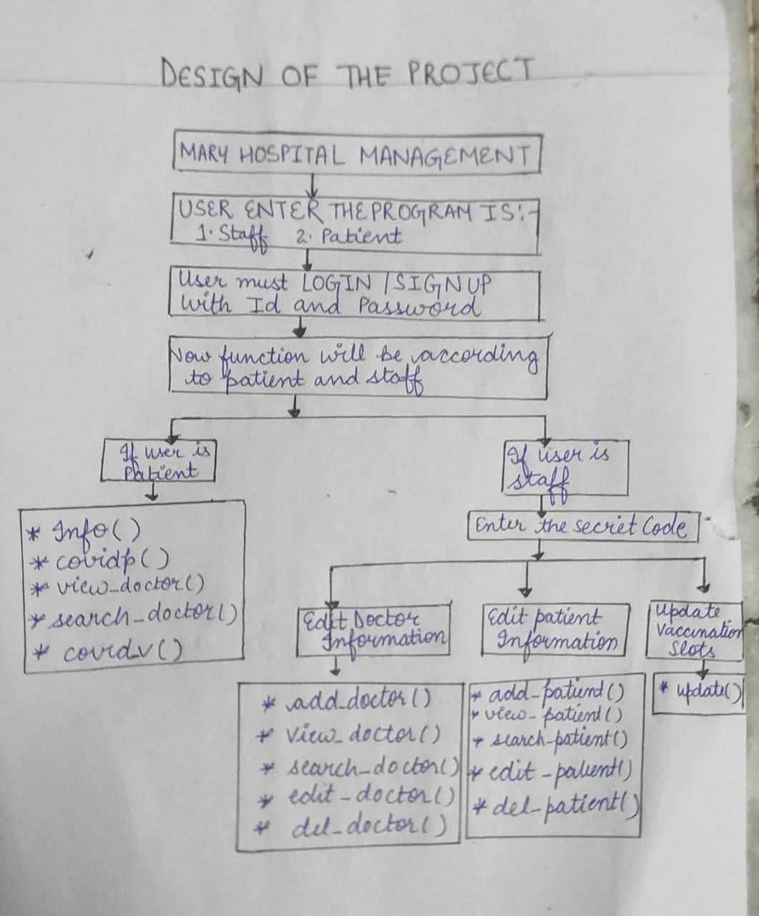

THANK YOU.